- Www.kfupm.edu.sa/name

- Physics Faculty login:
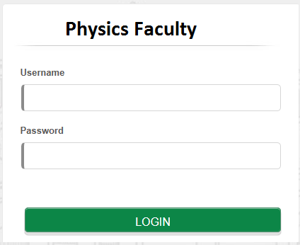

- Website pages

