Larmor Precession

When a pure static magnetic field is present and acting on a system of charges, the Lorentz force of the field on any charge is always normal to the direction of the motion of the charge, hence the magnetic field is not able to change the energy of any charge. In other words, the magnitude of the momentum P is constant. In the nonrelativistic case $\frac{d\vec{P}}{\text{dt}}=q(\vec{v}×\vec{B})=\frac{q}{m}(\vec{p}×\vec{B})$. The direction of the momentum of the charges is changing in a plane normal to the magnetic field. In fact the momentum of any charge is precessing around the direction of the magnetic field by a frequency =$\frac{\text{qB}}{m}$. The magnetic moment of a charge in this case will be in the direction of the magnetic field. The situation becomes more complex when the charges have originally (before applying the magnetic field) a net magnetic moment in some other direction maybe due to another source of magnetic field or a permanent spin as in electrons. The applied magnetic field tends to make the magnetic moment of the charge aligned in its direction while the angular momentum associated with the magnetic moment of the charge tends to maintain its original direction. The net effect is that the magnetic moment precesses around the direction of the magnetic field. The situation is analogous to the motion of a spinning gyroscope that undergoes a precession under the force of gravity when its rotational axis initially is not vertical. The magnetic moment of a system of moving charges is defined as : $M=\frac{1}{2}q_{i}({\vec{r}}_{i}×{\vec{v}}_{i})$. Hence the magnetic moment is related to the angular momentum by the formula: $M=γL$, where is the gyromagnetic ratio defined as the ratio of the magnetic dipole moment to the mechanical angular momentum of a system. For classical systems it equals $γ=\frac{q}{2m}$. In quantum mechanics, the magnetic moment of an electron due to its spin is related to the spin by a similar relation but the gyromagnetic ratio is multiplied by a factor slightly larger than 2. Regardless of the value of $γ$, the torque exerted by the magnetic field on the magnetic dipole is expressed as: $N=M×B$. Since this torque is what causes the change in the angular momentum of the dipole , $N=\frac{\text{dL}}{\text{dt}}$, then $γL×B=\frac{\text{dL}}{\text{dt}}$. That means that the frequency of precession of the magnetic dipole $ω=γ\left|B\right|$.

The most important application of Larmor Precession is Nuclear Magnetic Resonance. When the permanent magnetic dipoles of the nuclei are subjected to a very strong magnetic field in a certain direction, the spin of the nuclei precesses around the magnetic field in either one of two directions, parallel to the field or anti-parallel. These two orientations are different in energy by $2μ_{z}B$. Where $μ_{z}$ is the projection of the magnetic moment of the nucleus in the direction of the field. When external electromagnetic radiation is applied, the anti-parallel nuclei can acquire a photon of energy $ℏf$ exactly equal to the difference between the two states and change its state to the other direction (spin flipping). After some time it can relax to its old state and emit a photon of the same frequency. The value of the magnetic field in the expression is the magnitude of the sum of the local weak field due to the magnetic moments of other nuclei and the strong polarizing field ($B=B_{\text{ext}}+B_{\text{local}}$). Nuclei in different environments (different densities of atoms around it ) have different local fields and hence different resonance conditions. Thus by changing the value of $B_{\text{ext}}$and scanning across the energy of photons emitted (same as energy of photons absorbed by the nuclei), the different environments of the atoms can be detected. This is helpful in spectroscopy. For example, in CH₃–CH₂–OH the Hydrogen nuclei have three different absorption peaks for the three different environments, CH₃ , CH₂ , OH. By irradiating the compound by a constant frequency signal and sweeping the value of the external magnetic field gradually, three different peaks will be detected in the radiated signal from the compound at different values of B_{ext} . This is called Magnetic Resonance Spectroscopy. As shown in figure(1), the resonance conditions for a bare proton is different from the proton in different chemical compounds. As implied by the figure, another possible scanning method is by fixing the magnetic field and sweeping the frequency of the irradiation signal.

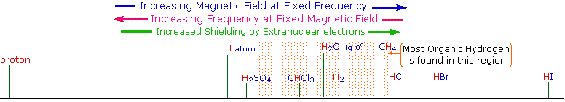
Figure (1)

Another important application is the Magnetic Resonance Imaging (MRI). In this application “an image of a cross-section of tissue can be made by producing a well-calibrated magnetic field gradient across the tissue so that a certain value of magnetic field can be associated with a given location in the tissue. Since the proton signal frequency is proportional to that magnetic field, a given proton signal frequency can be assigned to a location in the tissue. This provides the information to map the tissue in terms of the protons present there. Since the proton density varies with the type of tissue, a certain amount of contrast is achieved to image the organs and other tissue variations in the subject tissue.” Different frequency components are discerned from the detected signal by doing Fourir Transform to the radiated signal. A schematic diagram of this process is shown in figure (2).

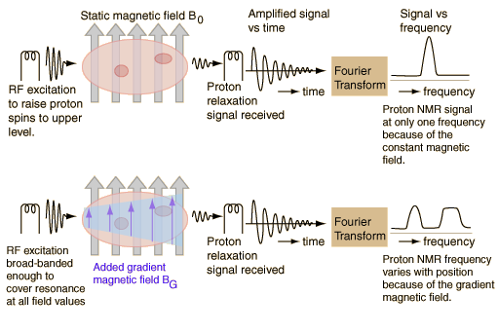
Figure (2).

References:
- http://www.cem.msu.edu/~reusch/VirtualText/Spectrpy/nmr/nmr1.htm
- http://hyperphysics.phy-astr.gsu.edu
- Classical Electrodynamics, J.Jackson
- Fundamental of Physics, Halliday, Resnick, Walker

